Title of Activity: Nissart Dialect

Summary:

Objective:
The objective of this activity is to strengthen students’ plurilingual skills.

Goal:
The goal of this activity is to encourage students to engage in all their previous plurilingual capabilities in order to decipher the meaning of the following sentences in the Nissart dialect. In order to do this they are asked to read some articles on what the Nissart Dialect actually entails and where it is spoken. Although this activity is designed with the Nissart Dialect in mind, it may easily beadapted to include other dialects as well, based on the instructor’s preference. The activity may easily be modified into an online activity (refer to image of storyboard below).
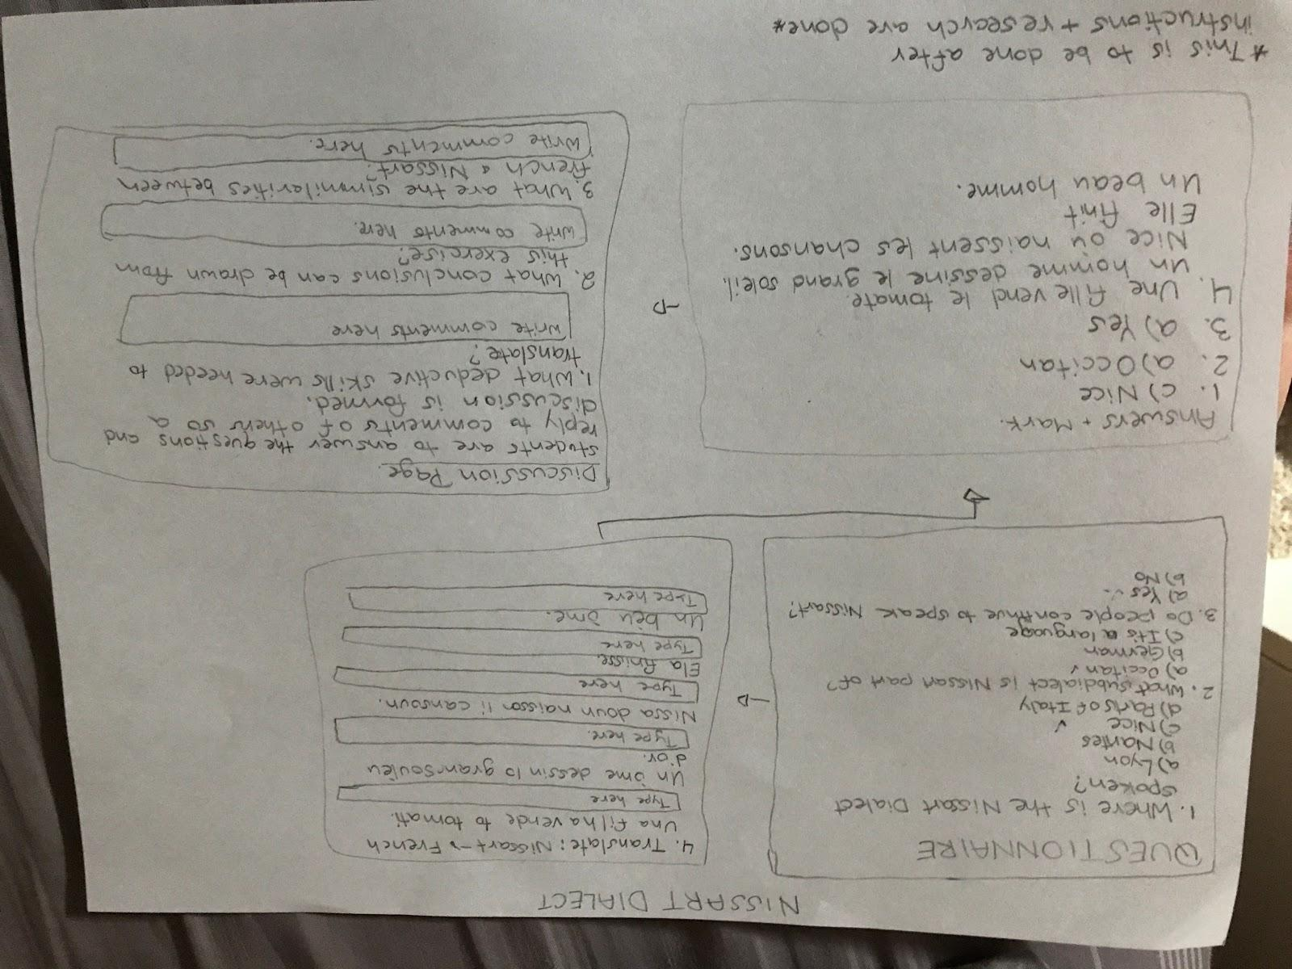

Key words:
- Interculturality
- Plurilingualism
- Languages
- Dialect
- Interpretation
Directions:
- The instructor should begin by directing students to form small groups of 3-4.

- Find articles and information regarding the dialect chosen. The examples in this activity are only using the Nissart dialect, but the instructor may decide to go with another dialect if they wish. Some resources are provided below for the Nissart Dialect but Wikipedia may be helpful as well. Students should learn the following background knowledge:
- Where the dialect is spoken.
- Basic geography and history of the region
- Why it is no longer spoken
- The mixture of languages it is composed of

- Using deductive skills, students should use their familiarity and knowledge of French along with other Romance languages to translate the following Nissart dialect sentences and words.
- Una filha vende lo tomati. [Une fille vend le tomate.]
- Un òme dessin lo gran soulèu d’or. [Un homme dessine le grand soleil d’or]
- Nissa, doun naisson li cansoun. [Nice, où naissent les chansons.]
- Ela finisse. [Elle finit]
- Un bèu òme. [Un beau homme]

- The instructor may wish to remind students to be mindful of the following to assist them with the translation process: what are the common sentence structures? Repeated words? Root of words? Etc. Students should refrain from using the internet for help and attempt to translate solely by relying on their own plurilingual capabilities.
- Once students have completed the exercise, the instructor may wish to discuss the following questions with students:
- What are some conclusions that can be drawn from this exercise?
- What are common similarities between the Nissart dialect to French and other Romance languages?
- What deductive skills were needed to translate the sentences?
- Any other final remarks?

Stage of the problem-solving process:
Highlight the appropriate stage(s) of the problem-solving process that this activity addresses.
- Define and articulate the problem
- Analyze the problem
- Develop alternative ideas
- Choose a resolution through negotiation
- Implement and test the resolution
- Evaluate progress of the resolution
Global competencies:
Highlight the global competencies addressed by this activity.
- Collaboration
- Innovation, creativity and entrepreneurship
- Learning to learn/self-awareness and self-direction
- Communication
- Critical thinking and problem-solving
- Global citizenship and sustainability
Plurilingual competencies:
Highlight the intercultural competencies addressed by this activity (at least one per category).
- Switch from one language to another
- Express oneself in one language and understand the other
- Call upon the knowledge of a number of languages to make sense of a text
- Recognise words from a common international store in a new guise
- Mediate between individuals with no common language
- Bring one’s whole linguistic equipment into play
- Experiment with alternative forms of expression in different languages and dialects
- Exploit paralinguistics (mime, gesture, facial expression, etc.)
- Simplify one’s use of language
- Exploit language as a tool for mediation to:
- Create pluricultural space for communication and learning
- Reducing affective blocks/tensions
- Building bridges toward the new, the other
- Co-constructing new meaning
- Passing on information (and simplifying, elaborating, illustrating or adapting)
- Acting as intermediary
Technologies:
Highlight the technologies used in the realisation of this activity.
- Web and Search Engines
- Open Source
- Open Educational Resources (OER)
- Analyzing Tools
- Databases and data analysis tools
- Cloud computing
- Communication Tools/Software
- Blog/Website
- Learning Management Systems
- Web/Video Conferencing Software
- Messaging Systems (Whatsapp, Google Hangouts)
- Social Networking and Content Curation Tools
- Group Work/Text Document Creation
- Cloud Storage (generally asynchronous)
- Collaboration (synchronous)
- Wiki
- Collaborative Mixed-Media Production
- Podcast
- Presentation Software
- Screencasting/Capturing
- Video Sharing
- Eportfolio
- Peer Review Software
- Assessment/Polling (e.g. Kahoot, Socrative, Quizlet)
- Production Software
- Graphics/Images
- Mind Mapping
- Note Taking
- Video Editing
- Audio Editing
- Curation
- Timelines
Resources:
http://www.sourgentin.org/
http://www.paisnissart.com/archives/langue_nicoise/index.html
http://nissart.info/
http://www.nice-la-belle.com/nissa_la_bella/index.htm

