Title of Activity: Breaking News

Summary:

Objective:
The objective of this activity is to practice language comprehension.

Goal:
The goal of the activity is to test students’ abilities to read and answer questions about world events using rapid fire technique.

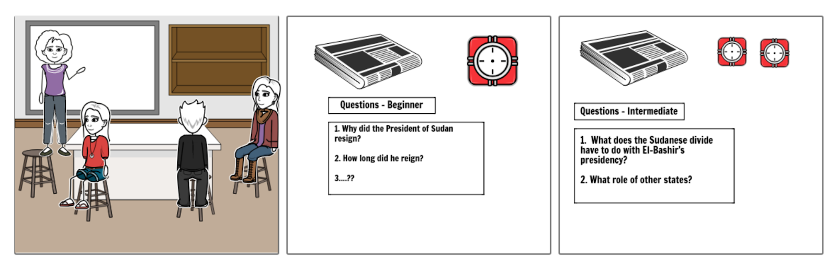

Key words:
- Interculturality
- Second Language
- Plurilingualism
Directions:
- The instructor will begin the activity by identifying a current topic and finding various sources that discuss the same issue at different lengths and levels of difficulty. Ideally, the instructor will also be able to provide French language sources.
- Students will then be tasked with reading the articles starting at the lowest level of difficulty within a short time frame. The instructor will determine a time that is challenging yet doable.
- The instructor will provide a set of questions based on the understanding of the text.
- The above steps will be repeated with the next text which should be on the same/similar topic (can be in accordance or disagreement), but that which is more difficult to understand. Students will be allotted a little more time in accordance with the length/difficulty of the text.
- These steps may be repeated for as long as there are related articles increasing in difficulty. Once at the last level, the class are encouraged to share and discuss their answers.
- The instructor should point out the distinction between native speakers’ comprehension and bilingual/second-language learners and encourage students to identify the misinterpretations, if any.
- This activity may be a precursor to Model United Nations simulation exercise. In this case, the instructor must tailor the activity to relate to the issues discussed in the context of the United Nations. This would give students an opportunity to learn about the topic beforehand, in way that tests their critical reading and comprehension.

Stage of the problem-solving process:
Highlight the appropriate stage(s) of the problem-solving process that this activity addresses.
- Define and articulate the problem
- Analyze the problem
- Develop alternative ideas
- Choose a resolution through negotiation
- Implement and test the resolution
- Evaluate progress of the resolution
Global competencies:
Highlight the global competencies addressed by this activity.
- Collaboration
- Innovation, creativity and entrepreneurship
- Learning to learn/self-awareness and self-direction
- Communication
- Critical thinking and problem-solving
- Global citizenship and sustainability
Plurilingual competencies:
Highlight the intercultural competencies addressed by this activity (at least one per category).
- Switch from one language to another
- Express oneself in one language and understand the other
- Call upon the knowledge of a number of languages to make sense of a text
- Recognise words from a common international store in a new guise
- Mediate between individuals with no common language
- Bring one’s whole linguistic equipment into play
- Experiment with alternative forms of expression in different languages and dialects
- Exploit paralinguistics (mime, gesture, facial expression, etc.)
- Simplify one’s use of language
- Exploit language as a tool for mediation to:
- Create pluricultural space for communication and learning
- Reducing affective blocks/tensions
- Building bridges toward the new, the other
- Co-constructing new meaning
- Passing on information (and simplifying, elaborating, illustrating or adapting)
- Acting as intermediary
Technologies:
Highlight the technologies used in the realisation of this activity.
- Web and Search Engines
- Open Source
- Open Educational Resources (OER)
- Analyzing Tools
- Databases and data analysis tools
- Cloud computing
- Communication Tools/Software
- Blog/Website
- Learning Management Systems
- Web/Video Conferencing Software
- Messaging Systems (Whatsapp, Google Hangouts)
- Social Networking and Content Curation Tools
- Group Work/Text Document Creation
- Cloud Storage (generally asynchronous)
- Collaboration (synchronous)
- Wiki
- Collaborative Mixed-Media Production
- Podcast
- Presentation Software
- Screencasting/Capturing
- Video Sharing
- Eportfolio
- Peer Review Software
- Assessment/Polling (e.g. Kahoot, Socrative, Quizlet)
- Production Software
- Graphics/Images
- Mind Mapping
- Note Taking
- Video Editing
- Audio Editing
- Curation
- Timelines
Resources:
https://breakingnewsenglish.com/1805/180504-language-learning.html

